WEEK 6 (POWER BI ADVANCED) Report
THEME: Advanced DAX & Executive Dashboarding
BY: Eunice Etefia
I built a 7-page interactive Power BI report that analyses sales dataset, covering 2.658bn in revenue, 735.4M in profit and 50,000 orders.
The report answers four questions: how the business is performing overall, which products and categories drive it, where it sells best, and who its most valuable customers are.
The report was built in Power BI Desktop, with the KPI cards driven by DAX measures. It uses slicers, bookmarks, drill-through and a custom tooltip page so that a reader can move from the company-wide view down to a single product or customer.
DAX Measures and KPIs
Every KPI card is driven by a DAX measure stored in the _Measures table, so the cards respond to the slicers instead of showing fixed numbers. The report uses 13 measures.
Measure | What it shows | Value
Revenue | Total net sales | 2.658bn
Profit | Total profit | 735.375M
Profit Margin | Profit divided by revenue | 28%
Orders | Number of orders | 50,000
Average Order Value | Revenue divided by orders | 53,162.77
YoY Revenue Growth | Revenue change against the same period last year
YoY Profit Growth | Profit change against the same period last year
MoM Revenue Growth | Revenue change against the previous month
Five supporting measures feed these cards: Revenue LY, Profit LY and Revenue PM (the prior-year and prior-month comparison values), Quantity Sold, and Revenue Trend.

Report Pages
The report has seven pages. Pages 1 to 4 are the main dashboards, pages 5 and 6 are drill-through detail pages, and page 7 is a tooltip page.
Page 1: Executive Overview
A one-screen summary of the business. It has eight KPI cards (revenue, profit, profit margin, orders, average order value, YoY revenue growth, YoY profit growth and MoM revenue growth) and a line chart of monthly revenue across all years, which stays between roughly 102M and 116M a month. Slicers for Year, Region, Category and Gender filter the whole page, and a Show Filter / Filter Hidden button pair (bookmarks) lets the reader hide the slicer panel.
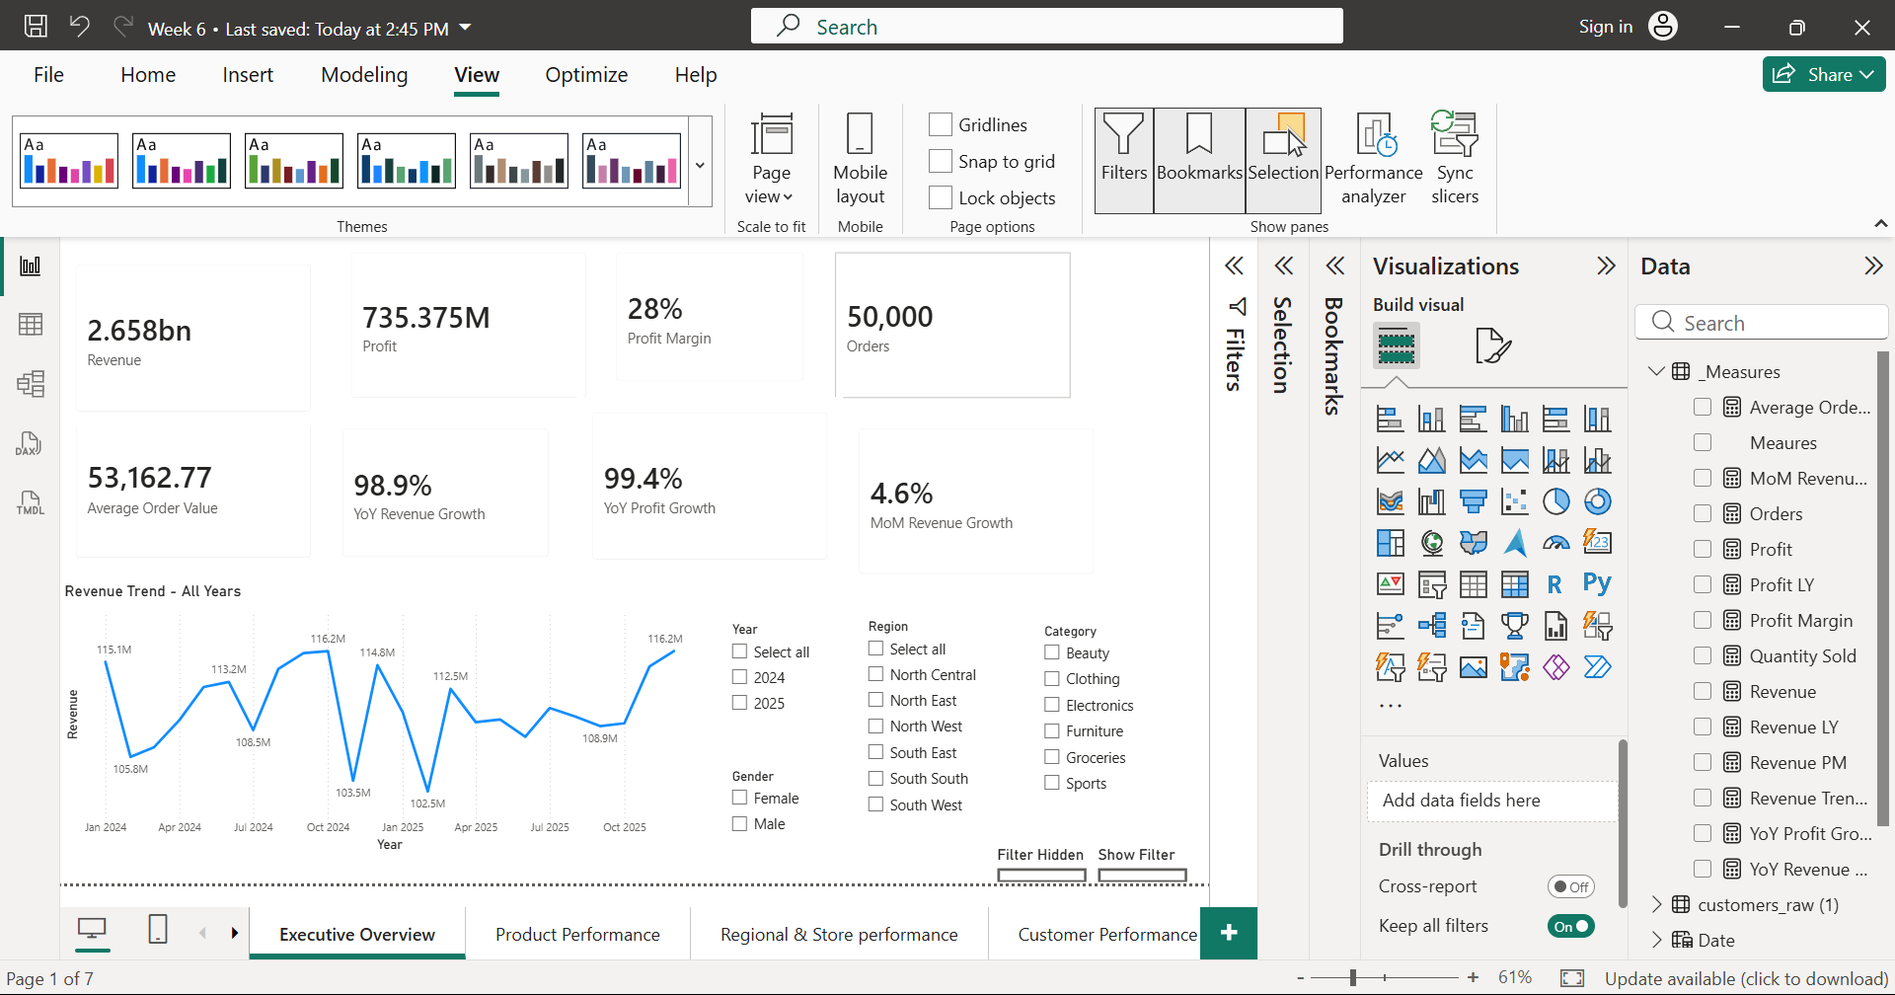
Page 2: Product Performance
Two bar charts rank the top 10 products by sales and by profit, led by Beverages Plus, Skincare Plus 34 and Chairs Basic 80. Two further bar charts compare the six product categories:

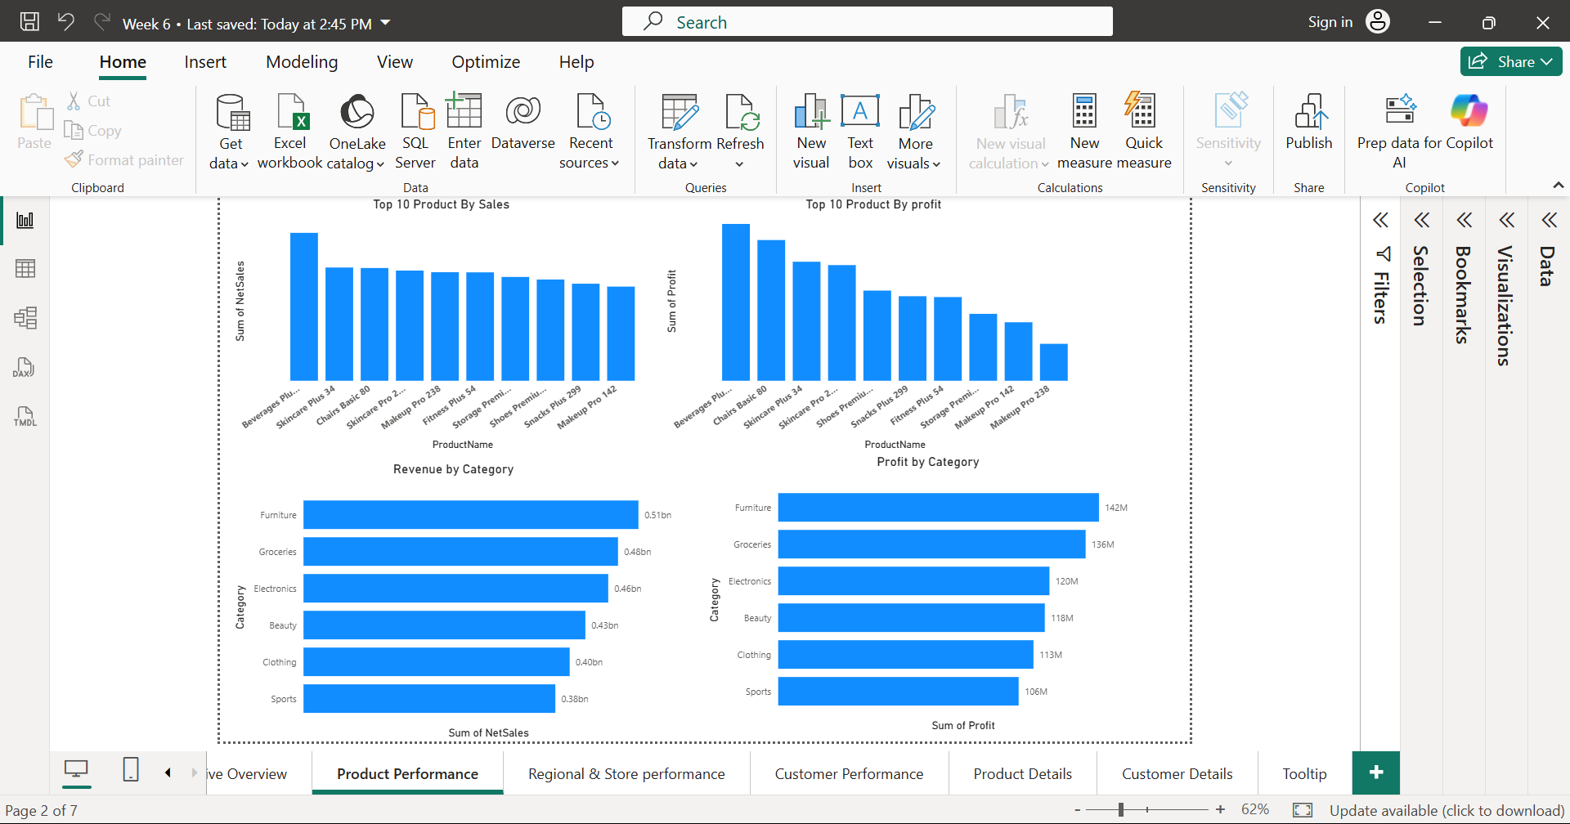

Page 3: Regional and Store Performance
Column charts show revenue and profit by region, and bar charts rank the top 10 stores. South West is far ahead of every other region.
Region | Revenue | Profit
South West | 1.70bn | 0.47bn
South South | 0.33bn | 0.09bn
North East | 0.31bn | 0.09bn
North Central | 0.11bn | 0.03bn
South East | 0.11bn | 0.03bn
North West | 0.10bn | 0.03bn
Ondo Retail Hub 25 is the top store by revenue, and Akwa Ibom Retail Hub is the top store by profit.

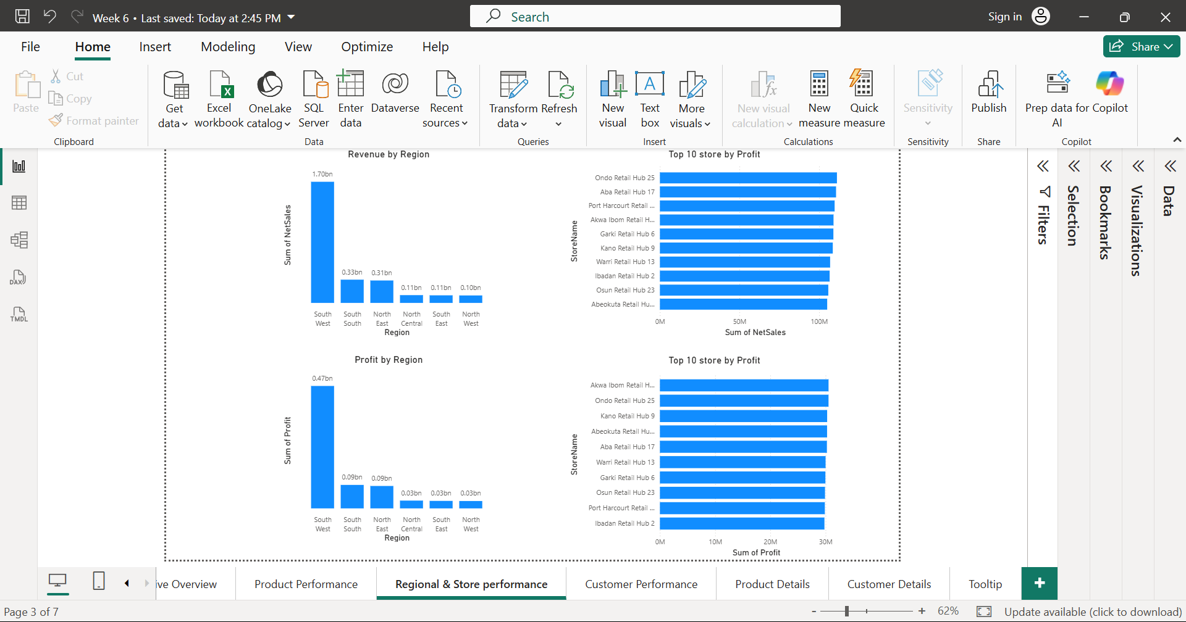

Page 4: Customer Performance
Bar charts rank the top 10 customers by revenue and by profit. Ngozi Balogun leads on revenue at 15.9M, while Daniel Olawale and Fatima Thomas lead on profit at 4.4M each. Two donut charts split revenue and profit by customer segment, and Region and Gender slicers filter the page.
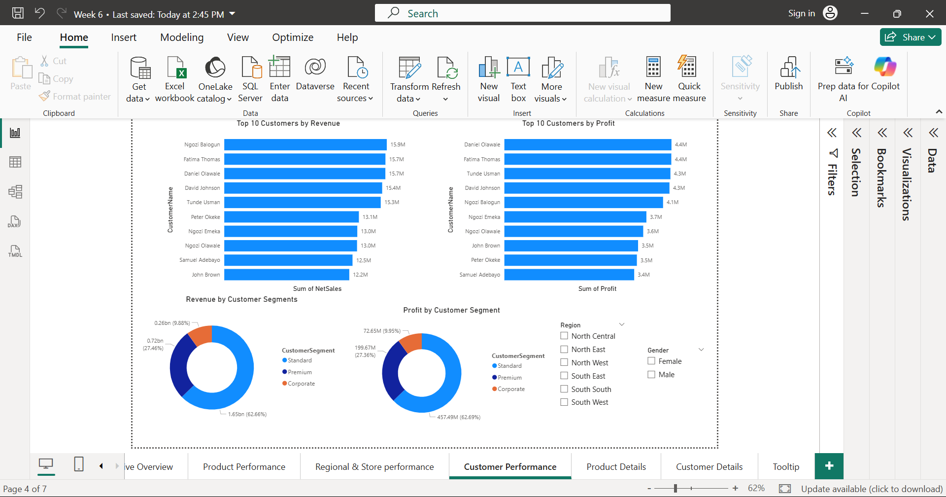

Page 5: Product Details (drill-through)
A reader right-clicks a product on the Product Performance page and drills through to this page. It shows five KPI cards for that product (revenue, profit, profit margin, orders and quantity sold) and a revenue trend line from January 2024 onward.
Page 6: Customer Details (drill-through)
A reader right-clicks a customer Name on the Customer Performance page and drills through to this page. It shows five KPI cards for that Customer (revenue, profit, profit margin, orders and quantity sold) and a revenue trend line from January 2024 onward.
A back button returns to Customer Performance.
Page 7: Tooltip
A small page used as a custom tooltip. When the reader hovers over a chart, it displays revenue, profit, profit margin and orders for the data point under the cursor, so the main pages can stay uncluttered.

Key Insights
- Healthy and consistent margin. Profit margin is 28% overall, and category margins sit in a tight band (Furniture 142M profit on 0.51bn revenue is about 28%; Sports 106M on 0.38bn is about 28%).
- Revenue is concentrated in one region. South West brings in 1.70bn of 2.658bn, about 64% of all revenue, and 0.47bn of the 735M profit. The other five regions together contribute about 36%.
- Categories are close. Furniture leads at 0.51bn (about 19% of revenue) and Sports is last at 0.38bn, so no single category carries the business.
- Standard-segment customers drive the business. They account for about 63% of both revenue and profit. Corporate customers contribute under 10%.
- Revenue vs profit rankings differ. The top 10 customers by revenue and by profit contain the same names but in a different order, for example Ngozi Balogun is first on revenue but fifth on profit. Product rankings shift too: Makeup Pro 238 is fifth by sales but last of the top 10 by profit.
- Strong growth. Revenue and profit are both up about 99% year on year, with month-on-month revenue growth of 4.6%. Monthly revenue is volatile, with clear dips and peaks across the period.

